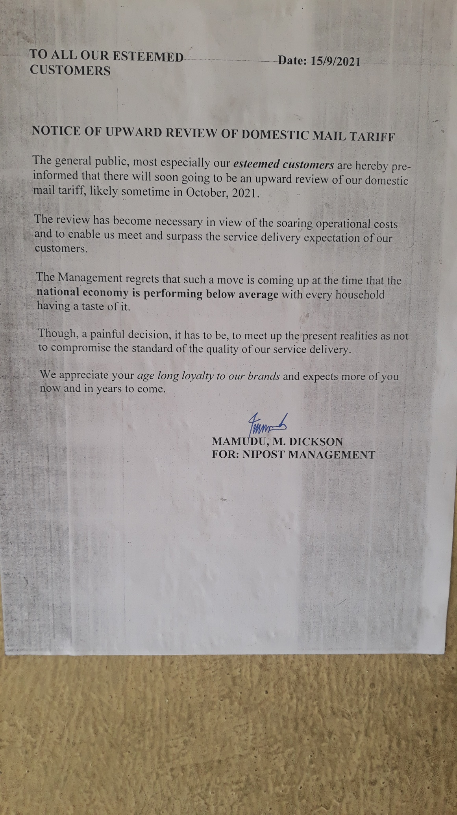https://von.gov.ng/2021/10/08/nipost-reviews-domestic-postage-rate/
29/10/21
- Note please:

-This tariffs were put to use for 2 days in August 2021 before it suspension.

- It's likely to be allowed for use again very soon probably from November 2021. I will inform us once that is done.

- Currently the old tariffs of N50 for internal mail is still in use.

Thank you All.

Eddy

